GIDDINGS & LEWIS

PiC Application Note

Document Number: 000043

Topic: MMC/Cimrex Application Quick Start Guide

The purpose of this application note is to jump start your MMC/Cimrex application. This also applies to PiC900/PiC90/Cimrex applications.
There are several examples applications that you can use as the base for your application. The PiCPro for Windows Applications CD Version 11.0.1 and higher have several 2 and 4 axis examples using the Cimrex 30 and an MMC. The Cimrex Prog CD Version 4.01 has a folder called: D:\BIN\MMC1DEMO which has two 1 axis examples using the MMC and a Cimrex 20, 30, 69 or 91, using both the serial and Ethernet protocols.
At the end of this application note are two appendices which are the readme.txt files for the two CD’s. I know no one ever reads these, but there is a lot of good information on these examples in them. It will save you development time if you review them.
We are going to use the MMC1_OI example ladder and the MMC1_C30 Cimrex application as our application. The following is a step by step guide on opening up the application and downloading the examples to both the MMC and Cimrex. We will also include several user tips along the way.

Requirements
The following software should be installed on your PC.
- PiCPro for Windows 11.0 SP1 or higher. Note the Service Pack can be downloaded from our web site: http://www.glcontrols.com/downloads/servicepak/servicepak.asp
- Cimrex Prog Version 2.21 or higher. Note: Current version is 4.10.
- PiCPro for Windows Applications CD Version 11.0.1 or higher. MMC or PiC900/90 and a Cimrex OI.

Getting Started
- Start PiCPro for Windows.
- Go to File Open and select the following project file:
D:\BIN\MMC1Demo\MMC1_OI.PRJ
The following screen should be displayed.
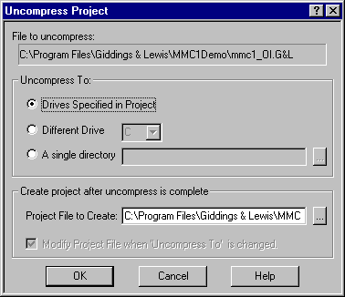
- Click on the Ok. A folder called C:\Program Files\Giddings & Lewis\MMC1Demo will be created and the project file will be uncompressed into this folder. The project contains the MMC PiCPro and Cimrex OI files. The project window will now be displayed as follows.
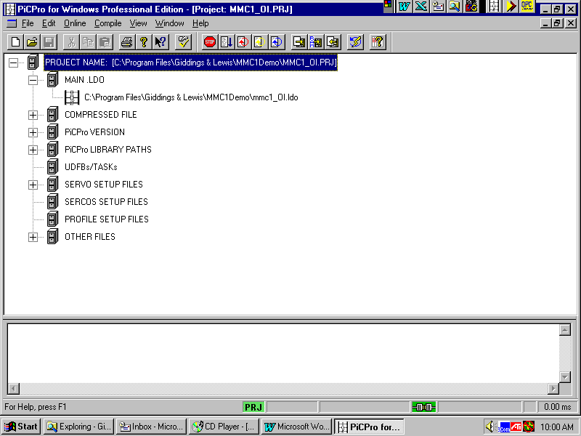
Tip 1 – When you open a project, PiCPro will automatically setup your PiCPro Libraries and Compile settings for you. This is saved with the project.

- Click on Window – Main Ladder – [MMC1_OI.ldo], the ladder window will now be displayed.
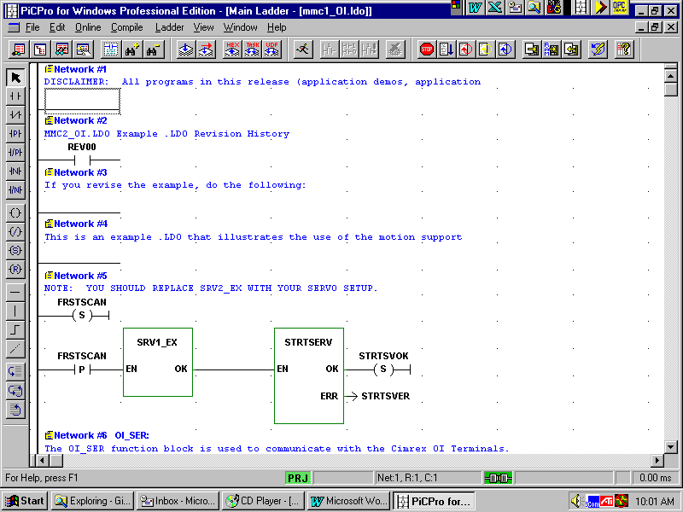

- The OI_SER ASFB is used to process the message from the Cimrex, which is in network 6.

Tip 2 – Use on-line help for a description of the OI_SER function. This can be used for any function or function block. Scroll down to network 6 and right click on the function. Select Help.

- PiCPro will generate a tag name list that can be imported into the Cimrex application. To generate this file you have to go to Compile-Settings. Below is the Compile Settings Window.
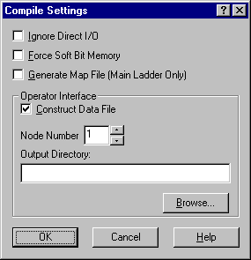
Under Operator Interface you have to check the Construct Data File box and set the Node Number to a non-zero value, as show above. You can leave the Output Directory blank. By default the OID file will be generated in the same directory as the ladder. Click OK to exit. Note these settings are saved with the project.
- When the ladder is complied and downloaded a file with the extension .OID will be generated. This file will contain a list of all software declarations that had a Global Attribute. Note: you should only give the software declarations that you want the Cimrex to access a Global Attribute. To set the global attribute in software declarations, put the cursor in the A. column for the variable and type “G”. You can also do this under Tools-ModifyAttributes-Global.

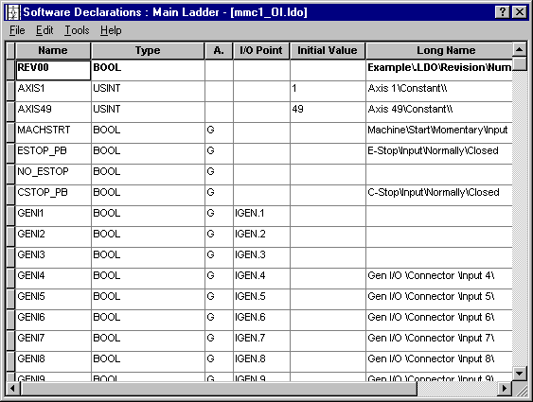

- To download the ladder select, Compile-Bin File-Compile and Download. The following window will come up.
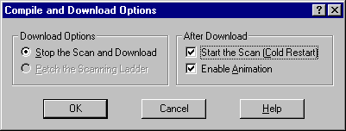
Check the Start the Scan box and click on OK to download. After the ladder is downloaded the MMC is ready to respond to commands from the Cimrex.
- If you PC has only one COM port you will have to close PiCPro before running Cimrex Prog.
- Open up Cimrex Prog.
- NOTE: Cimrex Prog 4.01 and higher will automatically install the G&L drivers.
If you haven’t installed the MMC/PiC driver, refer to Appendix B - INSTALLING THE G&L DRIVER. See we’re going to get you to read the readme.txt one way or another.
- Open the MMC1_C30 application under, File Open and browse to:
C:\Program Files\Giddings & Lewis\MMC1Demo\MMC1_C30.
Note, there are also applications for the Cimrex 20, 69, and 91 for the MMC1_OI ladder. The following screen will be displayed.
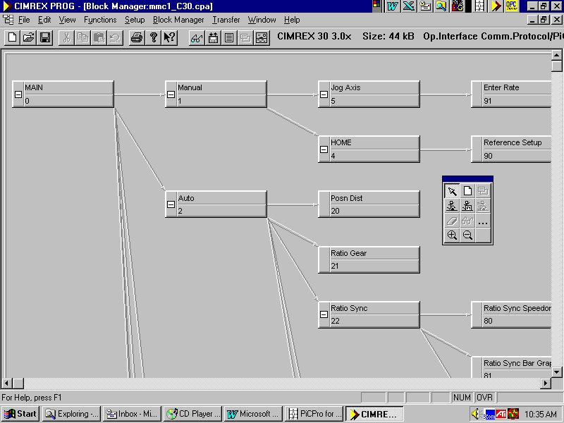
- The G&L OI_SER driver is a tag name based protocol. The OID file that was generated by PiCPro when the ladder was compiled can be imported into your Cimrex application. Go to View-Name List. The node number and Tag name will be displayed for each variable. The following window will be displayed.
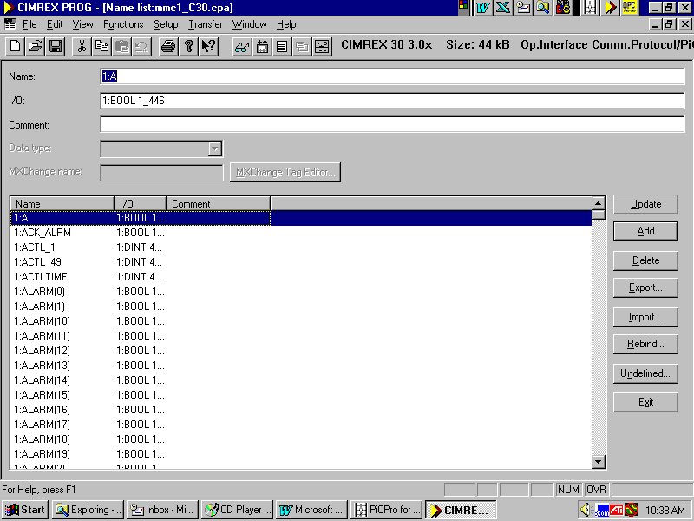
- Import the OID file by clicking on the Import button and browse to:
C:\Program Files\Giddings & Lewis\MMC1Demo\MMC1_OI.OID.
Open the file. The following windows will be displayed click on Ok or yes to import the file.
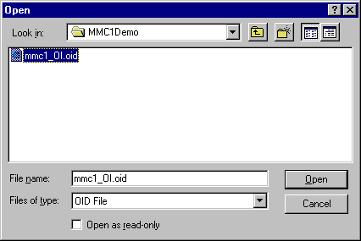
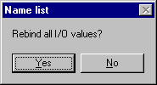
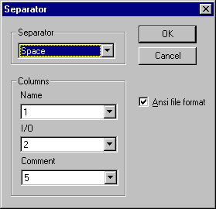
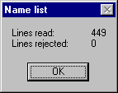
Tip 3 – Any time you make add, delete, or move any global variables in your software declarations, you must import the OID file after compiling the ladder. The OID file contains the list of global variables, each variable is assigned a index number that is used in the protocol. The OID file has checksum that is also used in the protocol. If the checksum in the Cimrex application doesn’t equal the checksum in the MMC/PiC the OI_SER function will return error number 1 to the Cimrex and no data will be exchanged.

- Click on the exit button to close the Name List window.
- To download the application to the Cimrex OI, click on Transfer-Project. The following Window will be displayed.

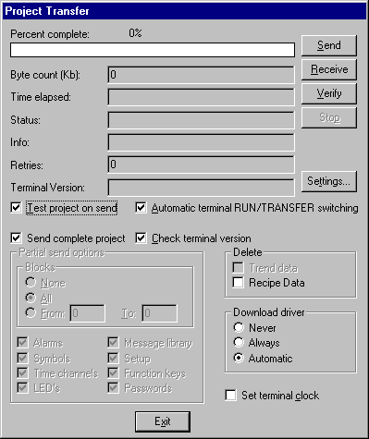
To change the COM port click on the Settings button. To download or transfer the application click on the Send button.

Tip 4 – The first time you power up a Cimrex OI you will get a screen that has two selections Edit and Transfer. Select Transfer to put the OI in the Transfer mode. After this all you have to do is have the OI connected to the PC and click on the Send button. The OI will automatically switch into transfer mode. Note: a Comm Error will be displayed on the OI since it is no longer connected to the MMC.
- Connect the OI to the MMC and press the Enter key to restart the application. The main block or screen should be displayed as follows on the Cimrex.
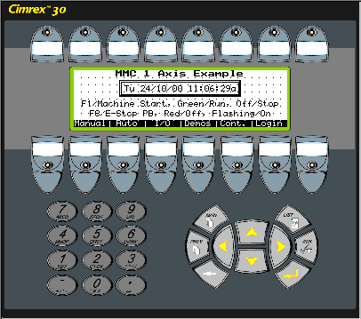
- This example uses most of the functions and features of the Cimrex. Take a few minutes and go through the demo to get a feel for the capabilities of the Cimrex OI.
Tip 5 - Don’t Re-Invent the Wheel. Frequently, we get calls from customers writing a PiC or MMC application from scratch. It’s not necessary to re-invent the wheel! There are a number of pre-written applications on the PiCPro for Windows Application Software CD that can give you a jump start and save you some time. And, if you use them, it saves us time too because we are intimately familiar with these programs and it will be easier for us to help you troubleshoot your application. The purpose of each example is to provide a foundation for your application. Each example provides all the basic features that most applications require:
- Loading the servo configuration
- Closing the servo position loops
- Handling emergency stop and control stop conditions
- Jogging the axes
- Referencing (or homing) the axes

Typically, the ladder logic required for a specific application is added to the end of an example. Refer to Appendix A for a description of these applications.

Appendix A - PiCPro for Windows Applications CD Version 13.0.1 Readme

TABLE OF CONTENTS
DISCLAIMER TECHNICAL SUPPORT NEW FEATURES/CHANGES UPGRADE FROM VERSION 12.0.x TO 13.0.1 OPC_ENET.LIB and OPINTER.LIB DUPLICATION CONTENTS OF THE APPLICATIONS CD STARTING A NEW MMC APPLICATION FROM AN MMC EXAMPLE DESCRIPTIONS OF THE STANDALONE MMC EXAMPLES
BASIC APPLICATION EXAMPLES OPERATOR INTERFACE APPLICATION EXAMPLES SERCOS DRIVE INTERFACE APPLICATION EXAMPLE PRESS TRANSFER APPLICATION EXAMPLE STEPPER APPLICATION EXAMPLE CENTURION DEVICENET POSITIONING MICRODSM DRIVE APPLICATION EXAMPLE
SERVO SETUP ASSISTANT

DISCLAIMER:
All programs in this release (application examples, application specific function blocks (ASFBs), etc.) are provided "AS IS, WHERE IS", WITHOUT ANY WARRANTIES, EXPRESS OR IMPLIED. There may be technical or editorial omissions in the programs and their specifications. These programs are provided solely for user application development and user assumes all responsibility for their use. Programs and their content are subject to change without notice.

TECHNICAL SUPPORT
For technical support call Giddings & Lewis at 1 800 558 4808, 1 920 921 7100 or send an e-mail to tech.support@giddings.com.

NEW FEATURES/CHANGES

- Added DSAPro - Drive Commissioning Software.
DSAPro is primarily used to configure and commission the DSA series servo drives. DSAPro can be used to select the proper motor for the drives as well as set up limits, and tune the drive for the application. DSAPro is also a useful tool for troubleshooting problems which may arise on the machine. When used to interface with an indexing drive, up to 64 indexes can be selected via the user selectable inputs. The axis can be homed using various methods. Registered index moves can be accomplished by simple fill in the box setup.
- Modified MMC Examples:
Fixed a timing condition in the E-Stop logic. If E-Stop became active on all of the axis in the same scan, ESTOPACT would not be energized due to ANY_CLSD being OFF and TIMING being ON. The ANY_CLSD contact was removed from the ESTOPACT network and TIMING is now reset when ANY_CLSD goes on. The LOOPTIME logic was also removed for enabling the drives. This logic is now in the M_CLOSx ASFBs.
- Modified SERCOS Examples:
Removed all reference to drive based digital I/O.
- Modified M_SCRVLC ASFB:
Added MVZD- zero distance move, FRTST- axis number of lowest active axis and FQUE- que number of lowest active axis' move outputs. Eliminated problem where time axis was not ready if M_SCRVLC was called twice between servo interrupts.
- Modified M_PRTREL ASFB:
K3/STANGL was not being added to the ASCII file because it was not being converted to a string.
- Modified S_CLOS1 ASFB:
Fixed an incorrect array index for axis 3 drive reset. The drive will now reset consistently.
- Modified S_ERRORC ASFB:
Removed the limit on the number of possible drive errors reported. Any drive error can now be reported.
- Added M_C2M UDFB and M_C2M_EX. Refer to the brief description of each standalone MMC example in the CONTENTS OF THE APPLICATIONS CD section of this document.
- Added E_TCPRD ASFB:
This function block is used to read data from a TCP connection via the Ethernet module. Since TCP is based on data streaming, not all of the data to be read may be available at any one time. The function block provides a convenient method of reading the stream data until the requested number of bytes are read.
- Added M_SACC ASFB:
This function block is used to calculate the ACC and JERK values to be used with the ACC_JERK function. Note: This function block is not intended to be used directly with the SCURVE or M_SCRVLC because the units for those functions are different (ACC is counts/min/min).
- Added SRV1_EX and SRV3_EX Servo Setup Files:
Created two new servo setup files for the example ladders.

UPGRADE FROM VERSION 12.0.x TO 13.0.1
If you are upgrading from the Applications CD version 12.0.x (1 or 2), you should do the following:
- If you have your files for the PiC/MMC applications located in a subdirectory under the Applications V12.0.x directory, you should move that subdirectory tree to under the new Applications V13.0.1 directory.
- If you have your application files organized using the PiCPro V12.0 project manager, change the PiCPro library path from the V12.0.x to the V13.0.1.

OPC_ENET.LIB AND OPINTER.LIB DUPLICATION
This distribution includes the OPC_ENET.LIB and the OPINTER.LIB and their ladder and help files. The OPC Server CD Version 2.0 and before, also includes these files (version 3.0 and later do not contain those files). If you have installed both software packages and PiCPro for Windows has been configured to use the libraries provided for both packages, PiCPro will notify you of the duplicate libraries any time it reads all the libraries in the configured directory paths (such as when PiCPro is started, each time a project is loaded, any time the PiCPro library path is changed, etc.).
In this situation, it is recommended that the directory path to the libraries provided by the OPC Server installation be removed from the PiCPro library list (both in the default list for PiCPro and the library list defined in each project). The OPC Server's copies of these files must be considered obsolete.
To resolve the duplication, run PiCPro from Windows and select the File | PiCPro Libraries... menu to remove the unnecessary reference to the OPC Server ASFB directory. For each project that uses the OPC Server ASFBs, select the PiCPro Library Paths for the project and select Modify from its right-click menu. Within the subsequent dialog, remove the OPC Server ASFB directory.

CONTENTS OF THE APPLICATIONS CD
This release contains the Motion ASFBs, General ASFBs, Ethernet ASFBs and Example Applications for the standalone MMC and the MMC for PC.
The following version 13.0.1 manuals can be found in the folder Manuals on your CD: Motion ASFB Manual, General Purpose ASFB Manual and Ethernet ASFB Manual. They are PDF files and can be opened, read, and printed using Adobe Acrobat Reader. Acrobat Reader can be downloaded free of charge from Adobe at http://www.adobe.com/supportservice/custsupport/download.html.
Note: You MUST use Acrobat Reader 4.0 or newer to view these manuals.
If you would like to order a hard copy of any manual, call PiC Sales at 1 800 558 4808 from within the US or 920 921 7100 from outside the US and Canada.
Part Numbers for the hard copies are:
- M.1301.0409 Motion ASFB Manual V13.0.1
- M.1301.0407 General Purpose ASFB Manual V13.0.1
- M.1301.0436 Ethernet ASFB Manual V13.0.1
Section 4 of the MMC tutorial covers the applications examples.
The PiCPro for Windows Applications 13.0.1 can be used with either PiCPro for Windows V13.0 (or higher) Professional or Standalone MMC Editions. The Examples folder has example projects for each edition of PiCPro.
The default folders when installing the Applications CD are:
C:\Program Files\Giddings & Lewis\Applications V13.0.1\ASFB
C:\Program Files\Giddings & Lewis\Applications V13.0.1\Examples
C:\Program Files\Giddings & Lewis\Applications V13.0.1\Tools
Note: You should not put any other files or applications into these folders.
The ASFB folder contains the Motion, General and Ethernet ASFBs.
The Tools folder contains the ServoSetupAssistant spreadsheet.
The Examples folder contains 8 standalone MMC examples or starter ladders and several simple examples for the Motion, General and Ethernet ASFBs. There are also 3 MMC for PC examples or starter ladders included, although these cannot be downloaded using the Standalone MMC Edition.
The following is a description of how the examples are named.
MMCxxxxx | Standalone MMC Application Example.
MPCxxxxx | MMC for PC Application Example.
SRCxxxxx | SERCOS Setup Example.
SRVxxxxx | Standalone MMC Servo Setup Example.
SRVPxxxx | MMC for PC Servo Setup Example.
ZSRCMMC | SERCOS Setup Example Library.
ZSRVMMC | Servo Setup Example Library.
xxxxxx.CPA | Cimrex Operator Interface Application Example.
xxxxxx.GLC | G&L DeviceNet Scanner Configuration Example.
M_xxxxxx | Motion ASFB Example.
G_xxxxxx | General ASFB Example.
E_xxxxxx | Ethernet ASFB Example.
U_xxxxxx | MMC Application Example UDFB.
<>The following is a brief description of each standalone MMC example (or starter ladder).
M_C2M_EX. The Cad2Motion ASFB, translates an M and G code format ASCII file into servo motion. Many applications require description of their motion path using CAD software. Third party pacakages (such as Gcode2000) will convert the CAD package DXF output to M and G code text files. M_C2M will translate the M and G code file to servo motion. Examples of applications include glue laying and textiles cutting. The Cad2Motion ASFB is not intended for application to metal cutting machine tools such as lathes and mills and therefore does not support features required by CNC applications such as cutter radius compensation, tool offsets and constant surface speed.
MMC4_EX. This example can be used as a starting point for a 4 axis application. It contains the logic required to initialize the servo axes, close the servo loops, jog an axis, and home an axis. It also contains basic E-Stop and C-Stop logic. This example does not have any operator interface support. All of the machine functions are performed with discrete I/O.
MMC2_EX. This example can be used as a starting point for a 2 axis application. It contains the logic required to initialize the servo axes, close the servo loops, jog an axis, and home an axis. It also contains basic E-Stop and C-Stop logic. This example does not have any operator interface support. All of the machine functions are performed with discrete I/O.
MMC4_OI. This example can be used as a starting point for a 4 axis application. It contains the logic required to initialize the servo axes, close the servo loops, jog an axis, and home an axis. It also contains basic E-Stop and C-Stop logic. This example uses a Cimrex 30 as an operator interface. The Cimrex application is called MMC4_C30.
MMC2_OI. This example can be used as a starting point for a 2 axis application. It contains the logic required to initialize the servo axes, close the servo loops, jog an axis, and home an axis. It also contains basic E-Stop and C-Stop logic. This example uses a Cimrex 30 or Cimrex 20 as an operator interface. The Cimrex applications are called MMC2_C30 and MMC2_C20 (for the Cimrex 30 or Cimrex 20 units respectively).
MMC4_SOI. This example can be used as a starting point for a SERCOS application having an operator interface device. It contains the logic required to initialize the SERCOS configuration, initialize the servo axes, close the servo loops, jog an axis, and home an axis. It also contains basic E-Stop and C-Stop logic. This example uses a Cimrex 30 as an operator interface. The Cimrex application is called MMC4_SC30.
MMC4_PT. This example shows how to apply the press transfer application specific function blocks. It contains the logic required to initialize the servo axes, close the servo loops, jog an axis, and home an axis. It also contains basic E-Stop and C-Stop logic. It also contains logic to configure and run the specified slave profile(s). This example uses a Cimrex 30 as an operator interface. The Cimrex application is called M4PT_C30.
MMC_STEP. This example shows how to apply the stepper block I/O module. It contains the logic required to initialize the stepper block and to control it. A single UDFB (U_STPRC) provides the control logic for a stepper axis. The features supported by the UDFB include home (zero reference), jog, move a distance, move to a position, control-stop, emergency-stop and c-stop/e-stop reset.
MMC_DND. This example shows how to apply the Centurion DeviceNet Positioning MicroDSM drive. It contains the logic required to initialize and run the DeviceNet network. Two UDFBs provides the control logic for a DeviceNet axis to jog, move a distance or move to a position. A third UDFB provides the DeviceNet scanner status details. This example ladder and DeviceNet configuration are both referenced in the MicroDSM with DeviceNet installation manual.
The following is a brief description of each MMC for PC example (or starter ladder).
MPC4_EX. This example can be used as a starting point for a 4 axis application. It contains the logic required to initialize the servo axes, close the servo loops, jog an axis, and home an axis. It also contains basic E-Stop and C-Stop logic. This example does not have any operator interface support. All of the machine functions are performed with discrete I/O. This example is almost identical to MMC4_EX.
MPC4_OI. This example can be used as a starting point for a 4 axis application. It contains the logic required to initialize the servo axes, close the servo loops, jog an axis, and home an axis. It also contains basic E-Stop and C-Stop logic. This example uses a Cimrex C30 with an Ethernet module as an operator interface. The Cimrex application is called MPC4_C30. This example is almost identical to MMC4_OI.
MPC4_SOI. This example can be used as a starting point for a SERCOS application having an operator interface device. It contains the logic required to initialize the SERCOS configuration, initialize the servo axes, close the servo loops, jog an axis, and home an axis. It also contains basic E-Stop and C-Stop logic. This example uses a Cimrex C30 with an Ethernet module as an operator interface. The Cimrex application is called MPC4_SC30. This example is almost identical to MMC4_SOI.
Note: for both of the MMC for PC with Cimrex examples, there will usually be a configuration change required before either works. The Cimrex configuration file calls out the Ethernet connection to the MMC for PC. However, the correct TCP/IP address of the PC hosting the MMC for PC is unknown. The actual host address must be verified in the Cimrex configuration before it is downloaded to the Cimrex unit.
The ASFB folder contains the Motion, General and Ethernet ASFBs.

STARTING A NEW MMC APPLICATION FROM AN MMC EXAMPLE
The following is a description of how to start a new application from a standalone MMC example.
To use one of the examples as a starting point for your application follow the steps below. The following procedure will use the MMC4_EX Professional Edition Project as the starting point. The target application will be called NEW_APPL and the servo setup library will be ZNEWAPPL; other appropriate names can replace these used in this procedure. The same steps can be followed with the PiCPro Standalone MMC Edition.
- Start PiCPro for Windows V13.0 Professional Edition.
- File | Open, MMC4_EX Pro Edition.PRJ. This will open up the project.
- Once the project is open, do a File | Save As and fill in the following fields:
- Destination PRJ
C:\Program Files\Giddings & Lewis\Applications V13.0.1\New_Appl\New_Appl.prj
This will be the name and folder for the new project.
- Destination G&L
C:\Program Files\Giddings & Lewis\Applications V13.0.1\New_Appl\New_Appl.G&L.
This is the file name of the compressed project. The compressed file can be stored on the MMC Flashdisk. This allows the end user the ability to open the project from the MMC without having the original source code.
- Change the destination folders for Main LDO, Lib Path, UDFB Source, Servo Source, and Servo Lib's from:
C:\Program Files\Giddings & Lewis\Applications V13.0.1\Examples
To
C:\Program Files\Giddings & Lewis\Applications V13.0.1\New_Appl
- Close the Save As Project by clicking OK.
- Expand the Main .LDO and double click on MMC4_EX.LDO. This will open the main ladder and do a File | Save As with the new file name NEW_APPL.ldo.
- In network 5 (the network with the STRTSERV function), right click on SRV4_EX and then View Servo Setup. Do a File | Save As to SRV4_NEW.
- Make any necessary changes to the servo setup and then do a Compile | Make Function. When prompted for the library name for the servo function, change the name to ZNEWAPPL.
- Close servo setup.
- Replace the SRV4_EX function with the new servo setup function you just created by clicking on Ladder |Functions | ZNEWAPPL | SRV4_NEW.
- Close the NEW_APPL ladder window and save the changes when prompted.
- Go to back to the project window and delete MMC4_EX from the MAIN .LDO and add NEW_APPL.ldo.
- Do a File | Update Project Tree to update the project.
- Close the project. When prompted to compress the application select No. You do not need to compress the project until you are ready to store it on the flash disk.
- Using Windows Explorer delete the MMC4_*.* files, the SRV4*.* files and ZSRVMMC.LIB file from the new project folder:
C:\Program Files\Giddings & Lewis\Applications V13.0.1\New_Appl
Note that if the application is using SERCOS-controlled servos, the above procedure is followed starting with MMC4_SOI with additional steps to replace the example SERCOS setup file.

DESCRIPTIONS OF THE STANDALONE MMC EXAMPLES
The following is a description of the functionality provided with each standalone MMC example.
The purpose of each example is to provide a foundation for a customer's own application. As mentioned above, each provides all the basic features of most applications:
- Loading the servo configuration
- Closing the servo position loops
- Handling emergency stop and control stop conditions
- Jogging the axes
- Referencing (or homing) the axes
Typically, the ladder logic required for a specific application can be added to the end of an example.
Which example is the best starting point depends on the specific application: how many servo axes are required and will an operator interface device be used?

Basic Application Examples
The following is a description of the two examples that lack an operator interface. They are MMC2_EX for a 2 axis MMC and MMC4_EX for a 4 axis MMC.
The initial network with the STRTSERV function loads the servo setup configuration. Each example ladder includes a servo setup example (such as SRV2_EX for a 2 axis MMC or SRV4_EX for a 4 axis MMC). Each application must have its own servo setup configuration. Typically, this configuration is unique for every application as each could have different ratios of programming units (i.e., inches, millimeters, degrees, etc.) to the servo feedback units, different travel limits, different servo PID gains, etc.
The M_CHK1 and M_CHK49 function blocks check which axes are configured within the loaded servo setup. These blocks make it easier to write sections of ladder code that support different numbers of axes; by checking the Booleans set here, the appropriate actions can be taken based on the axes that are configured.
The M_CLOS1 function blocks will close the position loops for the configured servo axes. This action also includes resetting any internal e-stop or c-stop servo conditions (a servo e-stop will open the position loop).
The M_STATUS and M_ERROR function blocks provide all the significant data for the servos in one place within the ladder. If the application is using the digitizing axis available with the MMC, there is a network that checks that axis for an e-stop condition (that can result from a 'loss of feedback' hardware error).
The STATUSSV functions provide the ladder with information regarding the state of the respective servo fast inputs. Each axis has a DC input provided with a 'fast input' capability - so that (when enabled) the axis can latch the axis position at the instant the DC input occurs, based solely on the input condition rather than on the ladder scan time.
The network with the ESTOPACT coil monitors for an emergency stop (or e-stop) condition. The purpose for this network is to ensure that if an e-stop condition is detected, all the servo axes will be e-stopped immediately.
The network with the CSTOPACT coil monitors for a controlled stop (or c-stop) condition. The purpose for this network is to ensure that if a c-stop condition is detected, all the servo axes will be c-stopped immediately.
The networks with the GEN_IO and AUX_IO labels provide a simple way to view all the MMC discrete input and output conditions using the ladder animation.
The subsequent networks provide support for jogging and homing the axes. When jogging, only one axis can be selected and it can jog in one of three modes: at a constant velocity, to a specific incremental distance, or as a follower to a handwheel. Note that jogging will stop when a travel limit is reached because an e-stop will occur (in the ESTOPACT's coil network). However, if the Machine Start push-button is being pushed at the same time as the jog button, the operator can jog off a specific over-travel. For instance when in velocity mode, if the axis is on the plus over-travel switch, the axis cannot jog in the plus direction but it can jog in the minus direction.
The last networks in the basic examples provide support for the referencing (or homing) of the servo axes. The M_FHOME function block supports a homing sequence for the axis using the axis fast input as the reference switch. The M_LHOME function block supports a homing sequence for the axis using a specific discrete input as the reference switch. Both function blocks are provided for each servo axis in the ladder with M_FHOME actually connected to the rail. If the M_LHOME functionality is desired, then its code fragment (the function block and the surrounding elements) can be cut and pasted over the M_FHOME area.

Operator Interface Application Examples
The examples having operator interface support (MMC2_OI and MMC4_OI) have more ladder logic than the basic examples. Early in the ladder, the OI_SER function block enables the MMC variables (in the main ladder) that are given the G (global) attribute to be shared with the operator interface device (typically a Cimrex terminal) connected via an RS232 serial connection. Note that the global attribute is also used when the MMC is connected to an external PC via the Ethernet module and the MMC shares its data with the PC using the OPC Server technology.
There are a number of networks that update the state of the ALARM() Boolean array. This array is used to provide immediate indicators to the operator interface device regarding specific ladder conditions.
After the axis jogging and homing section of the ladder, there are several networks involved with the saving and retrieval of the axis setup data using a RAMDISK file. Rather than having the various motion rates or reference positions hard coded within the ladder logic, they can be set by the operator and saved in a RAMDISK file, AXSETUP.DAT.
The examples conclude with a few networks that are the basis for supporting other Cimrex features: trending or graphing and the control of the LEDs.

SERCOS Drive Interface Application Example
There is an example provided for the 8 axis SERCOS MMC unit. This example (MMC4_SOI) is an extension of the 4 axis MMC example with an operator interface. For the support of the SERCOS drives, several different ASFBs are used.
At the start of the ladder logic, the SC_INIT function initializes the SERCOS ring connected to the MMC. Each SERCOS application must have its own SERCOS setup configuration. The example uses SRC_MMC4 for its 4 SERCOS axis configuration. For an actual application, this SERCOS setup function must be replaced with the actual SERCOS setup configuration. The programmer's steps to do that are very similar to those for replacing the servo setup, except that steps 7 through 10 in the above procedure (when STARTING A NEW APPLICATION FROM AN EXAMPLE) are done with SERCOS setup, not servo setup. The example uses SRV_MMC4 for its servo setup configuration. For an actual application, this servo setup function must be replaced with the actual servo setup configuration, as previously described.
The S_CLOS1 function block will close the position loop for the configured SERCOS axes. This ASFB is different for SERCOS axes because the SERCOS drive itself might have error conditions to reset before the position loop can be closed.
The S_ERRORC function block provides all the significant error information for a specific SERCOS axis. This ASFB is different than M_ERROR because a SERCOS axis has additional error information.
The S_FHOME and S_LHOME function blocks provide support for the referencing of the SERCOS axes. They are different than M_FHOME and M_LHOME because the latching of the reference position is done within the SERCOS drive.
The S_IO_C function block is unique to a Centurion SERCOS drive application because the additional discrete input and output points at the SERCOS drive can be made available to the ladder.

Press Transfer Application Example
There is an example provided for the press transfer ASFB set within the motion ASFB package. This example (MMC4_PT) is an extension of the 4 axis MMC example with an operator interface. There is a detailed 'readme' file for this example's user interface and the accompanying ladder logic; that file is MMC4_PT.TXT.

Stepper Application Example
There is an example provided for the stepper block I/O module. This example (MMC_STEP) is a simple ladder to illustrate the control logic for a stepper module.
The UDFB U_STPRC handles the overhead required for a stepper control. This UDFB handles the stepper home or zero reference, jog, move a distance, move to a position, controlled-stop, emergency stop, and a reset of a c-stop or e-stop.

Centurion DeviceNet Positioning MicroDSM Drive Application Example
There is an example provided for the Centurion DeviceNet MicroDSM drive. This example (MMC_DND) is a simple example to illustrate the logic to control the DeviceNet scanner and to control the DeviceNet drive over DeviceNet.
The ASFB M_DNJOGC handles the overhead required for the jog motion. The ASFB M_DNPOSC handles the overhead required for the motion of either a move of an incremental distance or a move to an absolute position. Note that both of these ASFBs are for the Centurion DeviceNet MicroDSM drive. Other DeviceNet drives will have their own unique DeviceNet interface (i.e., the respective boolean, byte and long-word tag name assignments in the scanner's memory map).
The ASFB M_DNSTAT extracts the details for the DeviceNet module status into individual bytes and booleans.
This example ladder is referenced in the MicroDSM with DeviceNet installation manual. It serves as the programming example for the MicroDSM with DeviceNet drive. The MMC_DND.GLC DeviceNet scanner's configuration data file is also referenced in the same drive manual to illustrate how to define the tag names for the DeviceNet drive's input and output data.

SERVO SETUP ASSISTANT

The Tools directory contains ServoSetupAssistant.xls. The ServoSetupAssistant is an Excel spreadsheet tool that makes creating your servo setup information a little bit easier. You specify machine parameters such as time base and precision in the ServoSetupAssistant spreadsheet. Based on these parameters the servo setup information for an axis is automatically calculated and can be imported into PiCPro for Windows using the new Import button that is provided under the 'Axis Data' tab. To use this spreadsheet:
- Do a File Save As to save this spreadsheet as a different name to maintain the original. A different .XLS file should be made for each axis in your application.
- Two sheets are provided for each type of axis that is allowed: Closed loop servo, Digitizing, and Closed loop SERCOS. The first sheet is used to input data, the second sheet holds the servo setup data that will be imported into PiCPro. You may delete the sheets for axes that are not being used. Double click on the tab for a sheet to change the name of the sheet to match the description of the axis.
- Enter the data for the axis. The setup information is being automatically calculated on the next sheet as you enter. Enter only information with pull down boxes or data that appears in blue. When you are ready to save the information for an axis select the sheet called 'PiCPro 'X' Setup Data' (where X is Servo, Digitizing or SERCOS Servo). NOTE: Before you save the file in .CSV format, you must save the entire workbook by doing a File Save to keep your edits. If you do not do this, all formulas and changes will be lost when you save the file in .CSV format.
- From the File menu select Save As and save the sheet under a different name, with file type .CSV (comma delimited variable). Excel will prompt you through the save process. All other sheets in the workbook and all formulas will be deleted in the .CSV file.
- Close the files in Excel.
- Start PiCPro for Windows. Import the data from the .CSV file by selecting the Import button under axis data.

Appendix B – Cimrex Prog Version 4.10 Readme.txt
Cimrex Prog Version 4.10 Build 120, G&L Serial Driver Version 3.11.3 and Ethernet Driver 3.13.1

NOTE: If this document does not display or print properly, please turn Word Wrap on.

IMPORTANT

It is important to read this document. It provides late-breaking product information
such as:
==>A list of features new to this release
==>Tips and helpful hints on using the product
==>Information so new it isn't in the documentation
==>Known problems and work-arounds

TECHNICAL SUPPORT

For technical support call Giddings & Lewis at 1 800 558 4808 or 1 920 921 7100, or send an e-mail to tech.support@giddings.com.

UPDATE DRIVERS

After installing Cimrex Prog you should check to see if there are newer versions of our Drivers. This can be done from Cimrex Prog - File Update Terminal Drivers from Internet or going to the Beijers web site: http://www.beijerelectronics.com and downloading the drivers.

NEW FEATURES

The following is a list of new features, refer to the manual for details.

Unicode support
Improved Multilanguage
New menu language
Terminal applet 1.20

Cimrex Prog 4.10 does not support the Cimrex 71.

It is replaced with the Cimrex 67 and 69. To open and convert a Cimrex 71 program you will have to install a Key. The folder "cd:\Bin\Cimrex Prog 4.x Cimrex 71 Key" contains the key.

To install the key:

Copy the software key to your hard disk
Close Cimrex Prog
Run C71.reg
Start Cimrex Prog
The Cimrex 71 is now in the selection list

MANUALS

The manuals can be found in the Folder "cd:\Bin\Manuals" and "cd:\Bin\Manuals\Drivers" on your CD. The name of the of the Cimrex Prog manual is CIMREX_E.pdf and the G&L Driver manual is GiddingsLewis_PiC_mmc.pdf. They are PDF files and can be opened, read, and printed using Adobe Acrobat Reader. It can be downloaded free of charge from Adobe at http://www.adobe.com/supportservice/custsupport/download.html.

There is also an Application Note called MMC/Cimrex Quick Start.Doc on the CD. This is a MSWord document which guides you through getting an application up and running.

The pin outs for the Cimrex to MMC/PiC cables are hard to read unless you zoom in, this will be corrected in the next release. The pin outs are as follows:

Cimrex PiC 10 Pin or
9 Pin Male MMC 15 Pin Female
---------- -----------------
2 ------------------ 9
3 ------------------ 10
5 ------------------ 8

EXAMPLES

The cd:\bin\MMC1Demo folder contains example applications for a Cimrex 30, 71 and 91, and the One Axis MMC Demo. There are also standalone versions of these that can be used for demo's, they do not require an MMC to be hooked up to the Cimrex OI. The examples are saved as G&L Project files.

Open up PiCPro for Windows 13.0 SP3 or higher. Go to File-Open and browse for the .G&L file(s)
MMC1_OI this project contains the serial driver and demo driver examples
MMC1_ETP.G&L this contains the Ethernet examples
Select the project you want to open, the project will be uncompressed to a the following folder: c:\Program Files\Giddings & Lewis\MMC1Demo

The PiCPro for Windows Applications CD also contains application example ladders and libraries you may find helpful in getting started. Read the readme file on that CD for instructions on using the examples.

Revision History

Date: 12/12/00
Author: Jeff Johnson

Changes: Original
Date: 02/28/02
Author: Jeff Johnson

Changes: Added note for Version 4.01 and higher automatically installing the G&L drivers.
Date: 04/07/03
Author: Jeff Johnson

Changes: Updated for Cimrex Prog Version 4.10 and PiCPro Applications 13.0.1

Date: [For each revision, enter the date revised,]
Author: [the name of the person revising the document,]
Changes: [and indicate what changes were made.]

